48 Port 1U Rackmount CAT5E UTP Modular Patch Panel (PPAN-48-THRU)
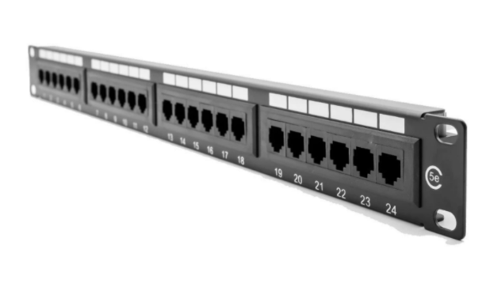

Description:
The LMS Data PPAN-48-THRU is 48 Port certified CAT5e UTP Patch Panel which is unique in that it has fully modular and replaceable CAT5eUTP ports. Simply snap in or snap out and mix and match with other accessories or when a port is damaged.

Fully Gigabit Ethernet certified means its ideal for running legacy and advanced networking protocols to Gigabit Switches up up to 1000Mbps. Also ideal for telecom, VoIP, CCTV-IP and other Ethernet based standards.

Long-life, nickel plated female RJ45s, the port modules use a through-coupler system so simply connect a RJ45 terminated cable to the rear of the panel.
Need a fast and easy way to connect your existing, RJ45 terminated cables in a data cabinet with the flexibility of a modular panel layout?
The new LMS Data PPAN-48-THRU is an innovative but costeffective solution for anyone looking to create a high-density, 19-inch Patch Panel. Each port is fully modular, simply clip in the CAT5e UTP module in the panel port holes and your ready to go. Ideal for when a fast LAN connection is needed and being modular means builtin fault redundancy - simply replace the offending through coupler module! Supplied with effective, snap-on rear cable management on the two panel levels means inbound cables are held securely at all times. Manufactured in both alloy/plastic composite for light weight and endurance.

Key Features:
- Certified CAT5E Performance for Gigabit Ethernet
- Fully modular, snap-in, snap-out RJ45 port system
- 2u High means it fits in the smallest of data cabinets
- Part of the Synthesis 25-Year Warranty Solution

Specifications
- 48-Port, High-Density 2-U Through Coupler Patch Panel
- Performance Cat5e UTP certified - Gigabit Compliance
- Easy-Clip, modular through coupler design*
- Meets or Exceeds current Category 5e performance
- Built-in LAN port redundancy - Easy to swap out
- High conductive, gold-plated RJ45 connections
- Individual port numbering (1-48)
- Supplied with x2 clip-on alloy rear cable management bars
- Supplied with standard M6 cage nuts, bolts and washers

Applications:
- Office, Education and Home Structured Cabling Installs
- Ideal for Gigabit Ethernet (1000Mbps) Data Networks
- Create fault tolerant LANs by simply patching ports

Product Code:
- Part Number: PPAN-48-THRU
- EAN: 8400800033512
- Weight: 1 Kg approx.

Technical Specifications:
- Port Count：48 Ports UTP
- Dimensions： 2U 19-Inch Design Format
- Design：Through Coupler System
- Performance：10/100/1000Mbps Gigabit Compliance
- RJ45/IDC Connects： Nickel and Phosphor Bronze
- Port Identification：Numbered
- Fixings ： Supplied M6 Nuts and Bolts
* Specifications and product design are subject to change. E&OE.

